文件打包具体整理过程

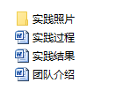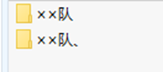C:\Users\pc\Documents\Tencent Files\1159614565\FileRecv\MobileFile\Image\3]W9YB)HVFC)}]DYZO61OF0.pngC:\Users\pc\Documents\Tencent Files\1159614565\FileRecv\MobileFile\Image\3]W9YB)HVFC)}]DYZO61OF0.pngC:\Users\pc\Documents\Tencent Files\1159614565\FileRecv\MobileFile\Image\U[9ZJ6IXE%L0QAX%7Z(]I3I.pngC:\Users\pc\Documents\Tencent Files\1159614565\FileRecv\MobileFile\Image\5}GLW9CR2M`}W~J%7XXYIZ5.pngC:\Users\pc\Documents\Tencent Files\1159614565\FileRecv\MobileFile\Image\0IM]N6_4$$$0G}81@D{L`~3.png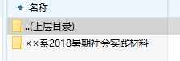C:\Users\pc\Documents\Tencent Files\1159614565\FileRecv\MobileFile\Image\XZ$GF~L$2XBK)6IX9{_]@YY.png